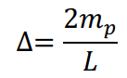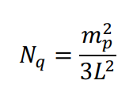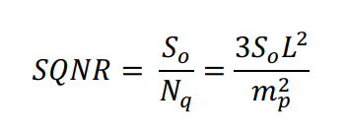

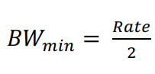

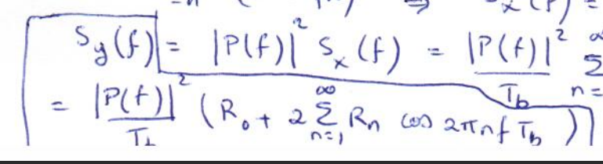

Polar Coding:

|  |  |
| --- | --- |
| BW | 2Rb(-wid 4x BWmin) or Rb(1-wid, 2x BWmin) |
| Power | Most efficient |
| DC | Not zero (but can be made zero w/ Manchester) |

ON-OFF coding:

|  |  |
| --- | --- |
| BW | Same as Polar |
| Power | 2x Power of Polar (or 4x Energy) |
| DC | Not zero |

Bipolar (single bit error)

|  |  |
| --- | --- |
| BW | Rb (No half-width pulse) |
| Power | 2x Power (3dB) |
| DC | DC Null |

Nyquist 1st Criteria ISI

sinc gives Rb/2 BW but falls off at 1/t, other functions have faster roll-off but (1+r)Rb/2 BW. Raised cos when r = 1,falls off at 1/t^3.

Controlled ISI

ZFE

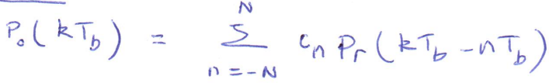

|  |  |  |
| --- | --- | --- |
|  | Multiamplitude | Orthogonal |
| Rate |  |  |
| BW | Independent of M | M |
| SNR (power) |  | Independent of M |

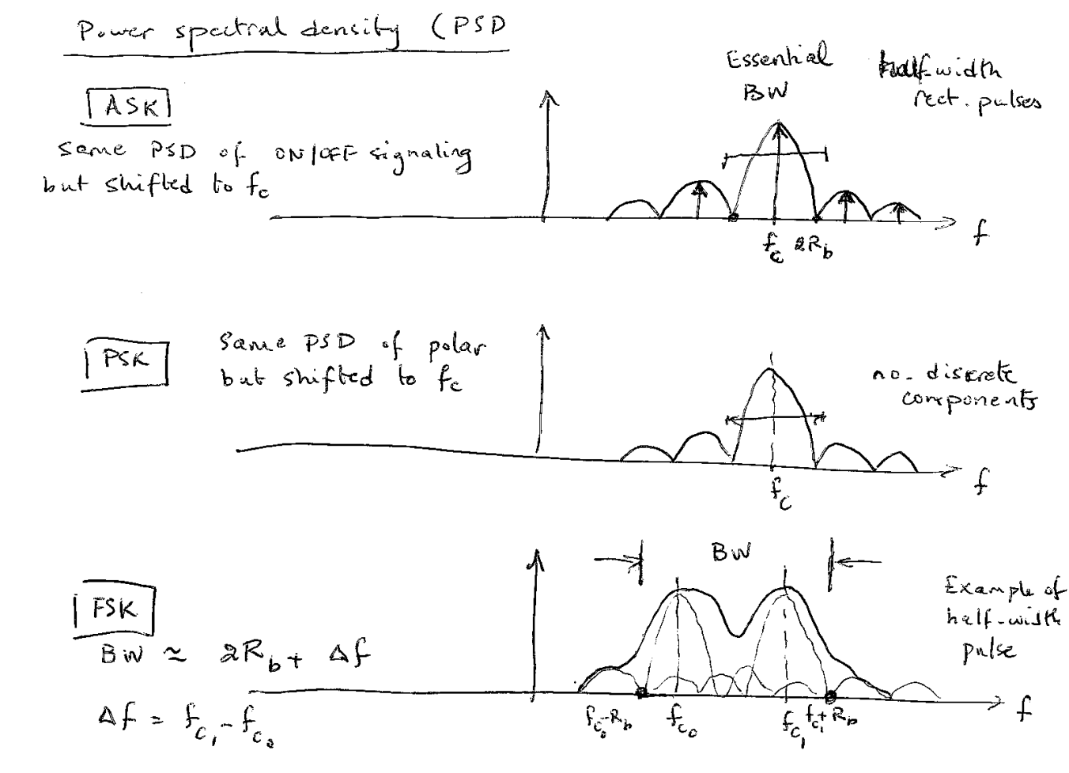

PSK requires 3dB less power than ASK(on/off). BW(FSK) > BW(ASK or PSK). Can’t use coherent demodulation for PSK but can for DPSK. DPSK 1 is same as previous bit and 0 is opposite.

FSK m-array, power const but BW increases with M linearly



PSK

